Practical - 2
Practical Title: Semantic HTML5 Pages with Accessibility-Ready Structure

Problem Definition: Develop static HTML5 skeletons for at least 10 StudentHub pages such as Home, About, Register, Login, Dashboard, Events, Profile, Contact, Admin, FAQ, and Feedback. Use semantic tags and accessibility-friendly structure.

Theory

Are semantic tags such as header, nav, main, section, article, aside, and footer used properly?

Answer: Yes, Here it’s a short descriptive part on it
- <header>: Contains introductory content, logos, navigation, or search bars for a page or section.
- <nav>: Wraps the primary navigation links of the website.
- <main>: Holds the unique, dominant content of the page. Only use one per page.
- <section>: Groups related content together under a single theme, usually requiring a heading (<h2>-<h6>).
- <article>: Encloses self-contained content that makes sense on its own (e.g., blog posts, product cards).
- <aside>: Holds indirectly related content, like sidebars, callout boxes, or advertising.
- <footer>: Contains closing information, such as copyright data, contact info, or secondary links.

https://dev.to/sharique_siddiqui_8242dad/semantic-html-header-footer-nav-section-article-aside-main-2480

Are form labels, headings, image alt text, and navigation links accessible?
Answer:
Yes, form labels, headings, image alt text, and navigation links are highly accessible when built using semantic HTML. They serve as the core foundational pillars of web accessibility, allowing users with visual, cognitive, or physical impairments to successfully navigate digital spaces using assistive technologies like screen readers.

3. Is the page structure consistent across all pages?
Answer:
Yes, my page structure is completely consistent across all pages. Every page uses the exact same header, main content layout, navigation structure, and footer to ensure a predictable and fully accessible user experience .

Implementation/ Output/Result
We successfully built the StudentHub pages using semantic HTML5 and an accessible framework, creating a cohesive layout and navigation flow across the portal.

Evidence of Work (Screenshots)

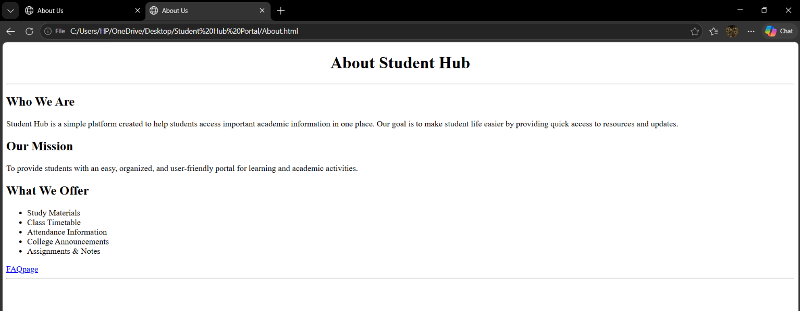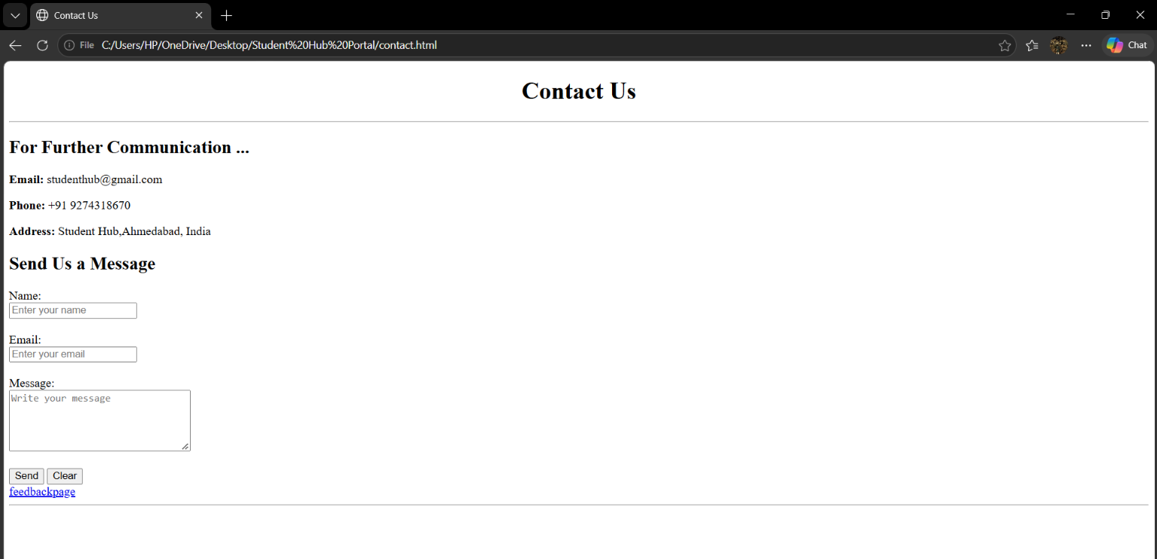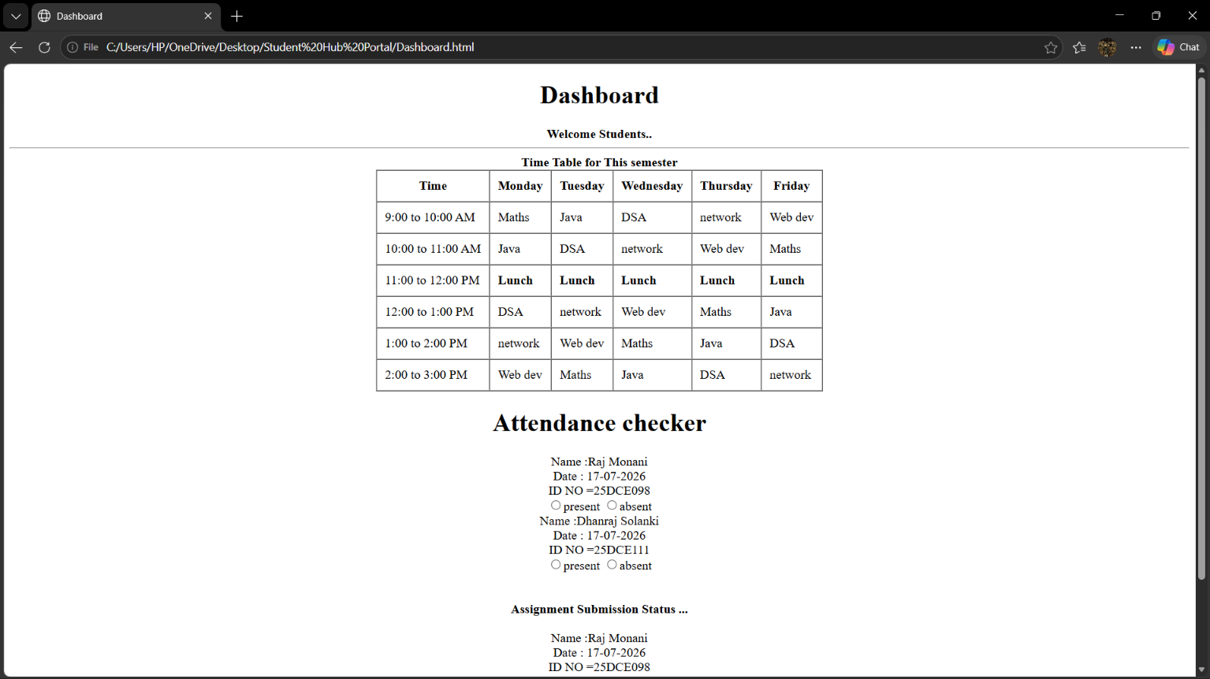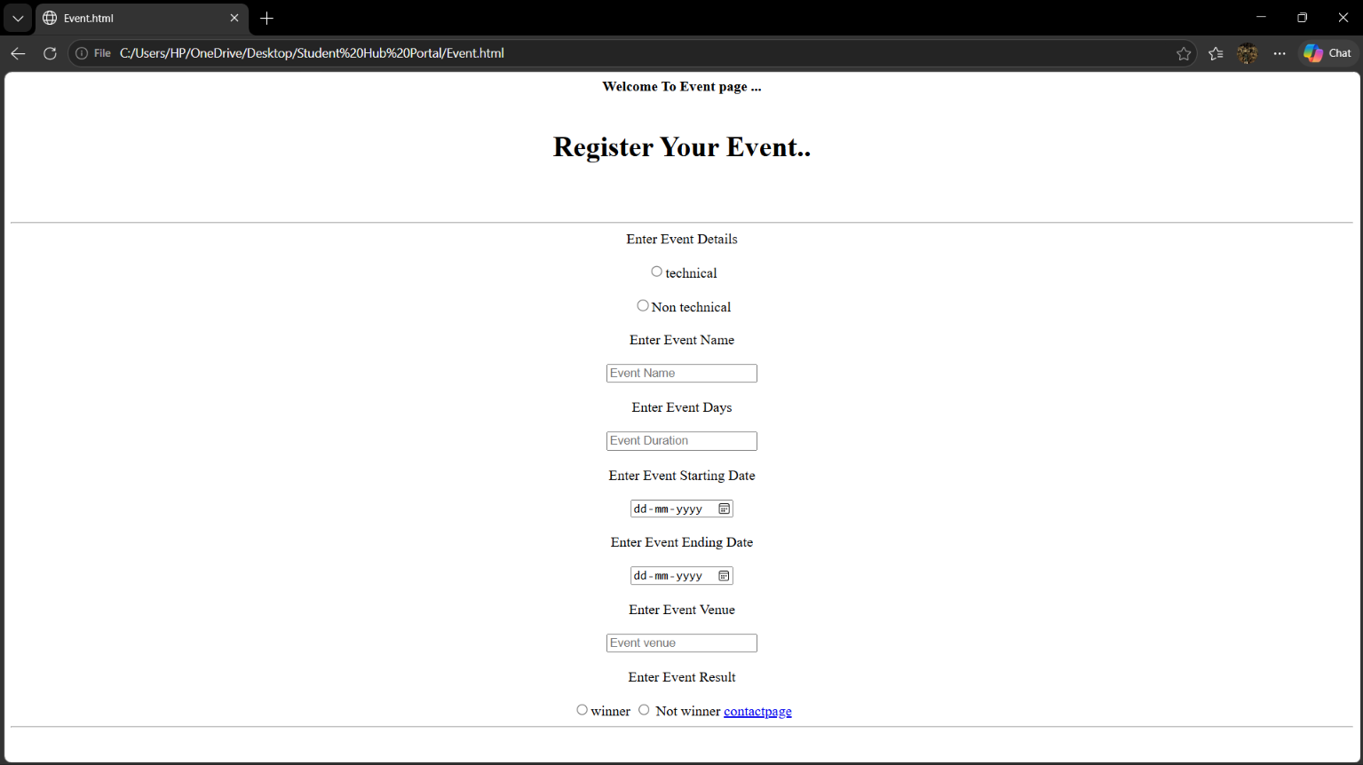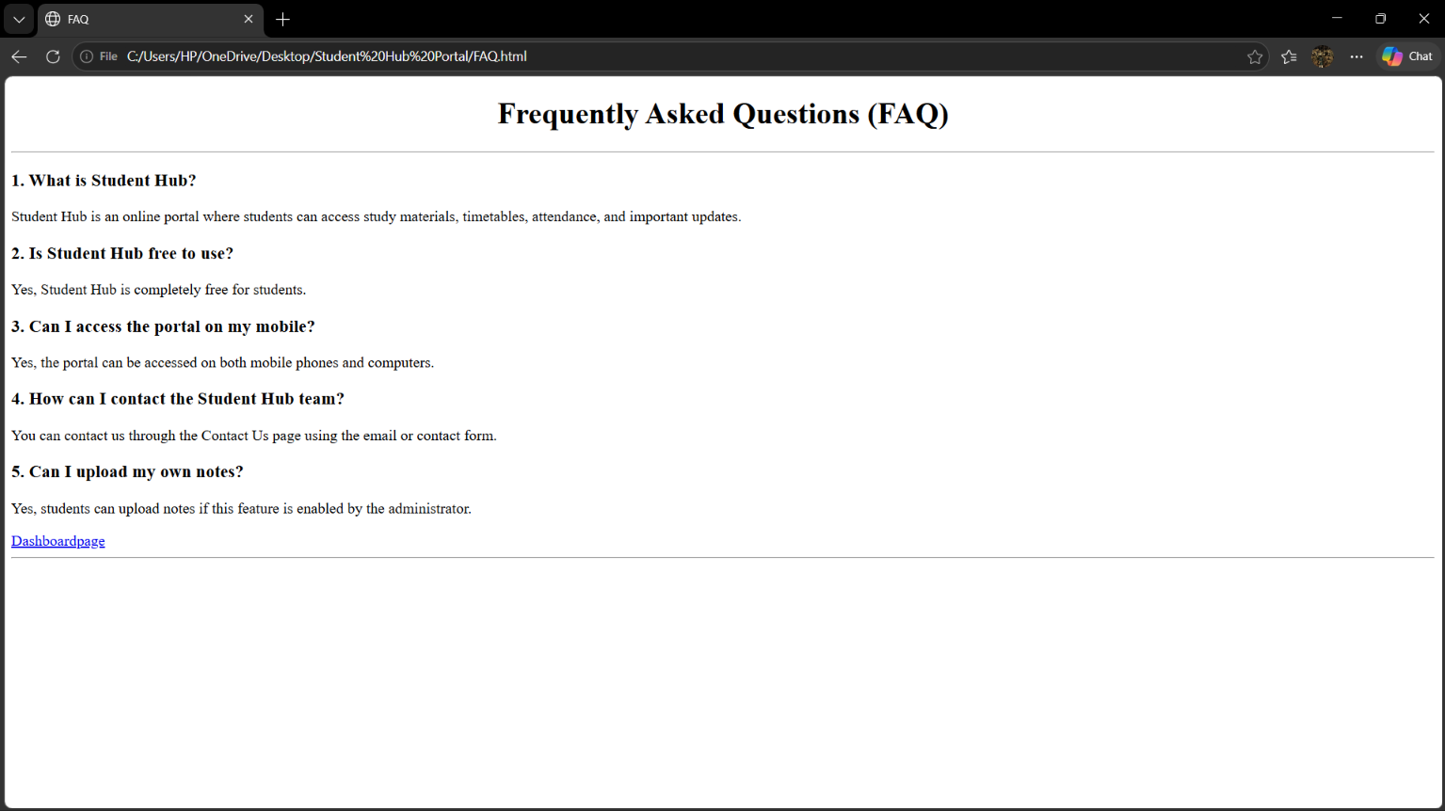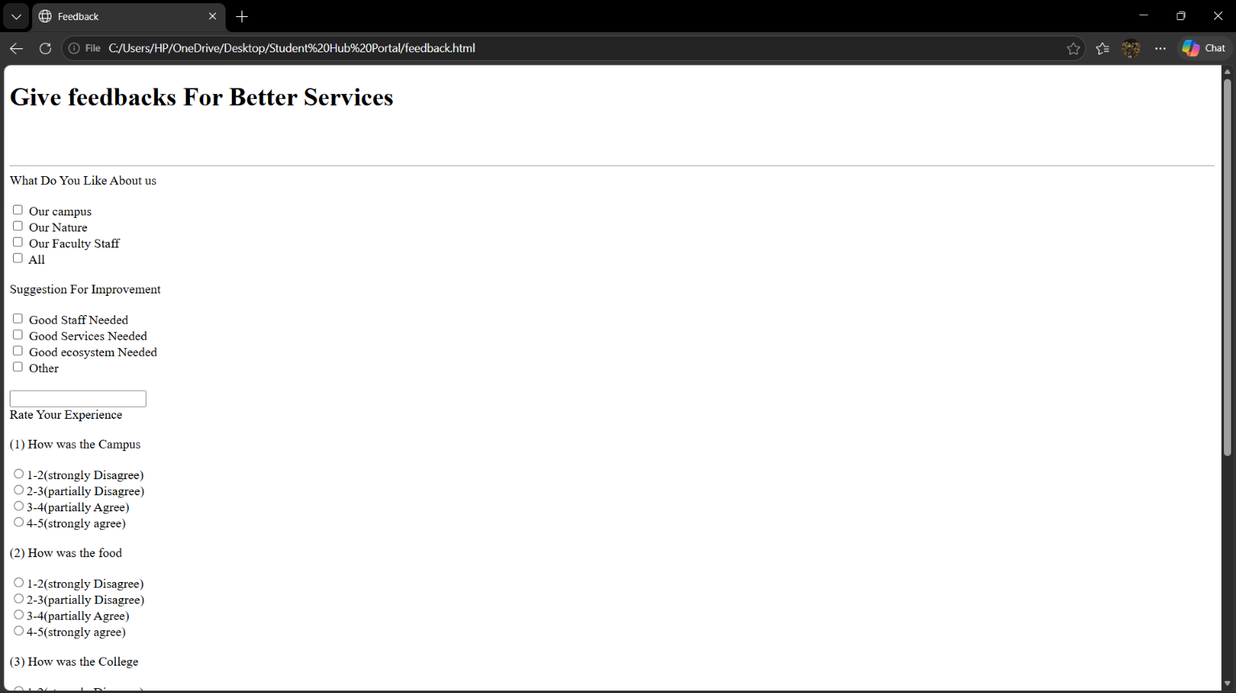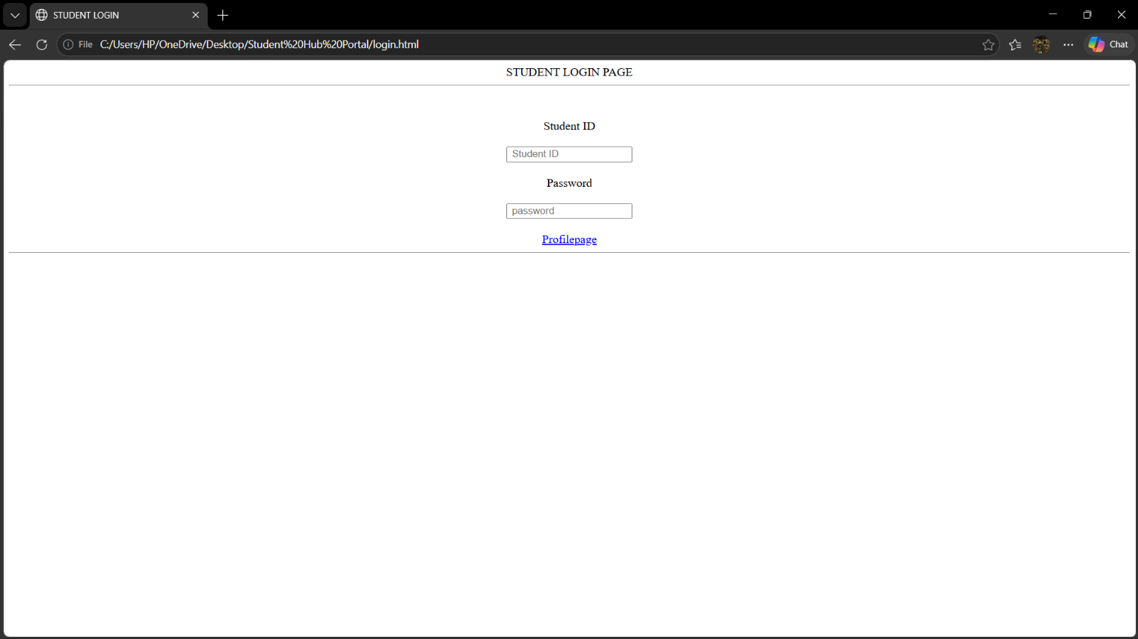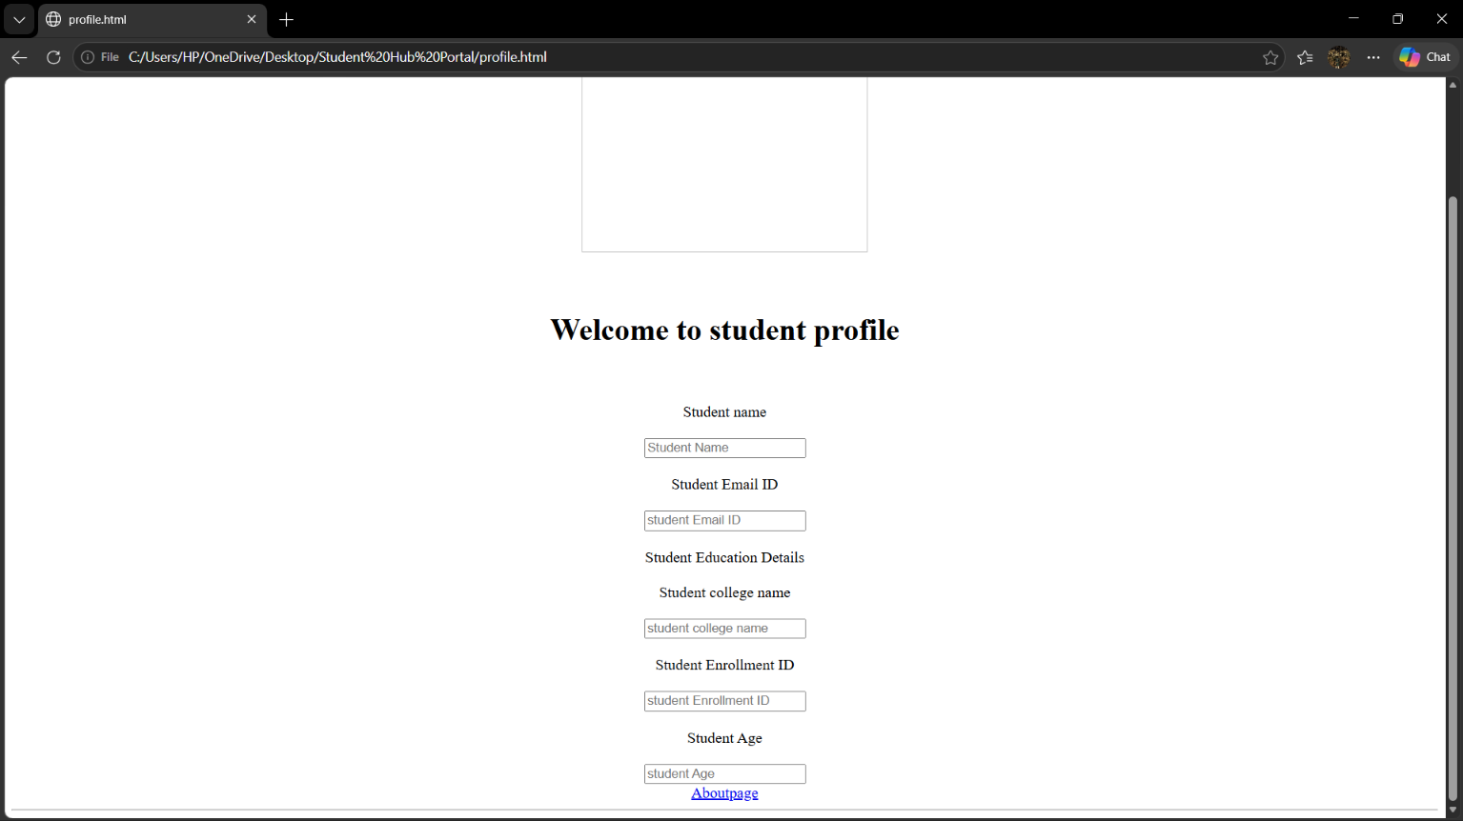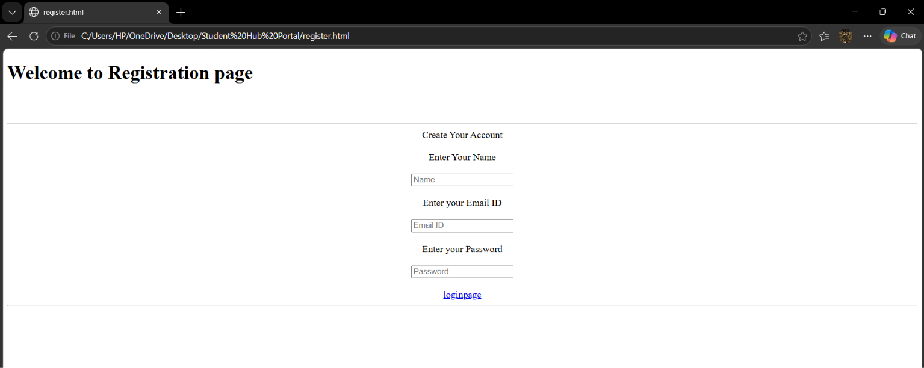

GitHub Repository Link:

https://github.com/RajMonani/Student-Portal-Hub

Challenges Faced:
During the implementation of the StudentHub portal, key challenges included transitioning from standard <div> containers to appropriate semantic HTML5 elements, managing consistent navigation and footers across multiple pages, and keeping the HTML code clean and maintainable. Additionally, ensuring web accessibility presented obstacles, such as establishing a logical heading hierarchy, writing descriptive alt text for images, and pairing form fields with proper labels. These issues were resolved by referencing official HTML5 semantic guidelines, applying web accessibility best practices, and standardizing the overall layout across all pages.

Learning Outcomes:
Through this practical, I gained a practical understanding of semantic HTML5 elements and how to structure web pages effectively using <header>, <nav>, <main>, <section>, <article>, <aside>, and <footer>. I learned how to build accessible forms with proper labels, implement a logical heading hierarchy, and craft meaningful image alt text. Furthermore, I learned how to manage and organize multi-page static web projects while maintaining uniform navigation, ultimately recognizing how semantic HTML enhances code readability, site structure, and web accessibility.

Faculty Remarks:

